# How to enable/disable 2FA for eCare

If any issues with the NotifyCustomer til cal, we will be disabling the OTAC functionality while login for the customers.

1. Login to Launch Darkly Site and Select the Environment: prod1 Common
2. Select the feature flags search bar search with “Enable: SMS Sending” as below screenshot
3. Turn on for disabling the OTAC
4. Turn off for enabling the OTAC
5. After selecting click on Save button

[https://app.launchdarkly.com/vfuk-consumer/prod1-common/features?q=sms sending](https://app.launchdarkly.com/vfuk-consumer/prod1-common/features?q=sms%20sending)

1. Please find the Below Screenshot

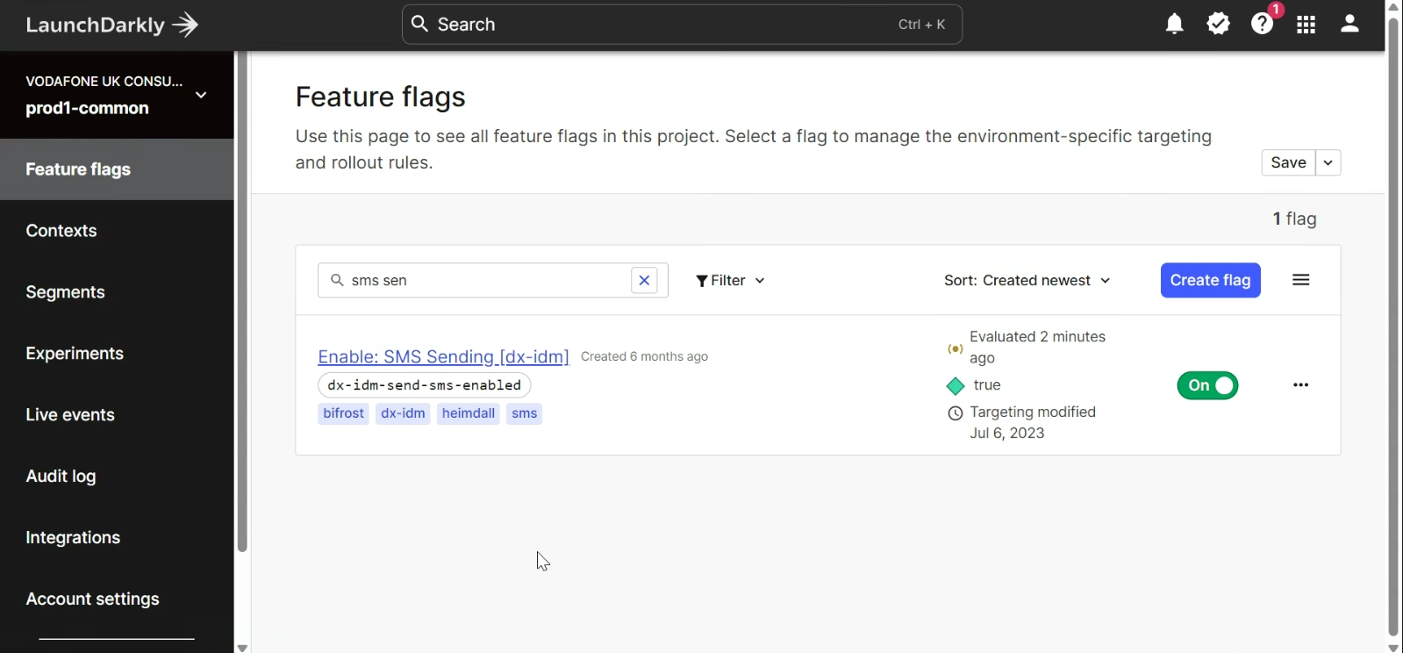

=====================================================================================

# How to enable/disable Feature Flag for AOM:

1. Select the Environment: prod1green and in the feature flags search bar search with dal-tmf-recommendation as below

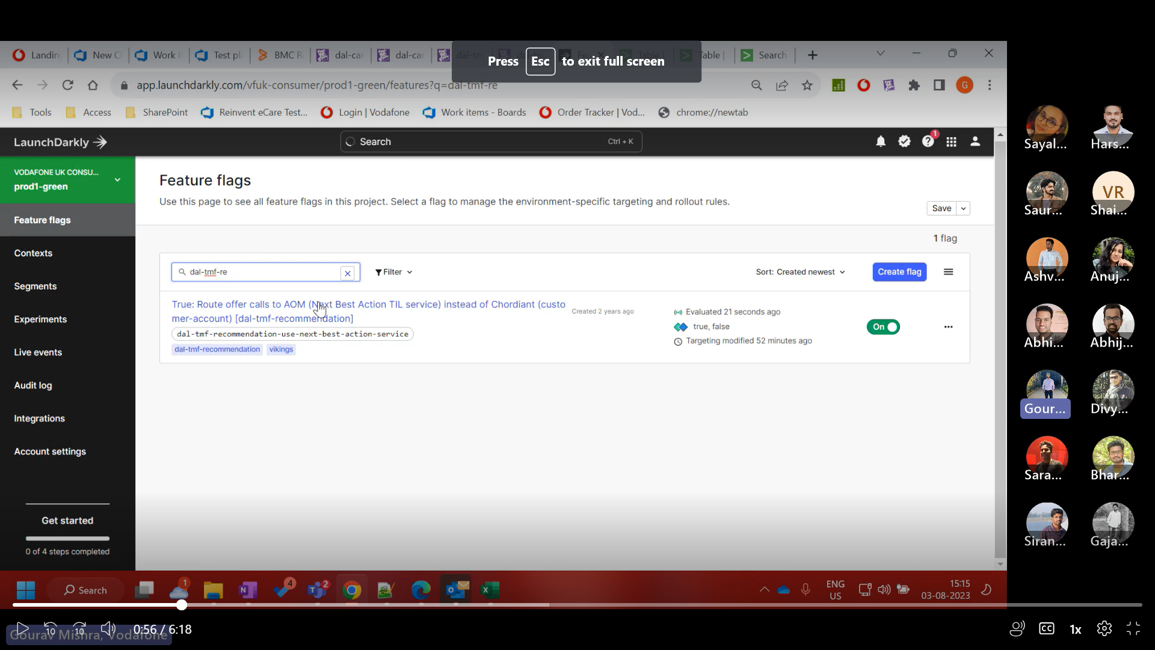

1. Scroll to the down and select the AOM ”eCare”

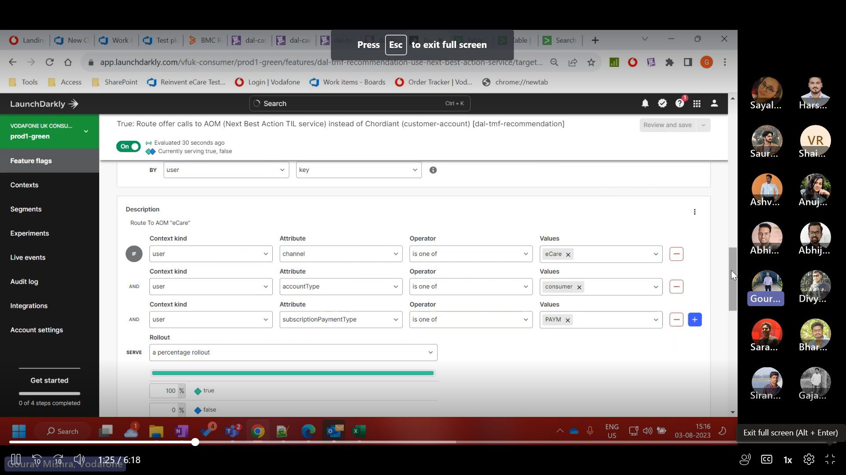

1. Now we can select the type of the Consumer like PAYM and if we want AOM to be 0 percent then in the False section we make it as 100%
2. For example, if we want to make AOM as 50% then in true section we make as 50% and in false section we make as 50% goes to Cordiant.
3. Post changing the values in the sections, we need to select the Button at top right corner in the above image as “Review and Save”
4. TRUE goes to AOM 🡪 dal-tmf-recommendation 🡪 GNBL, UNBL
5. FALSE goes to Cordiant 🡪 dal-customer-account 🡪 GMOL or UMOL

# How to enable/disable Feature Flag for Order:

1. Login to the Azure Devops with following link: [ORDER-V1.yml - Repos (visualstudio.com)](https://vfuk-digital.visualstudio.com/Digital/_git/dal-services-configuration?version=GBmaster&path=/prod1-green/ORDER-V1/ORDER-V1.yml)
2. Select the Repo of dal-service-configuration and navigate to the Prod1-green
3. Now select the “Order-v1” folder and find the ‘Order-V1.yml” file and select it accordingly 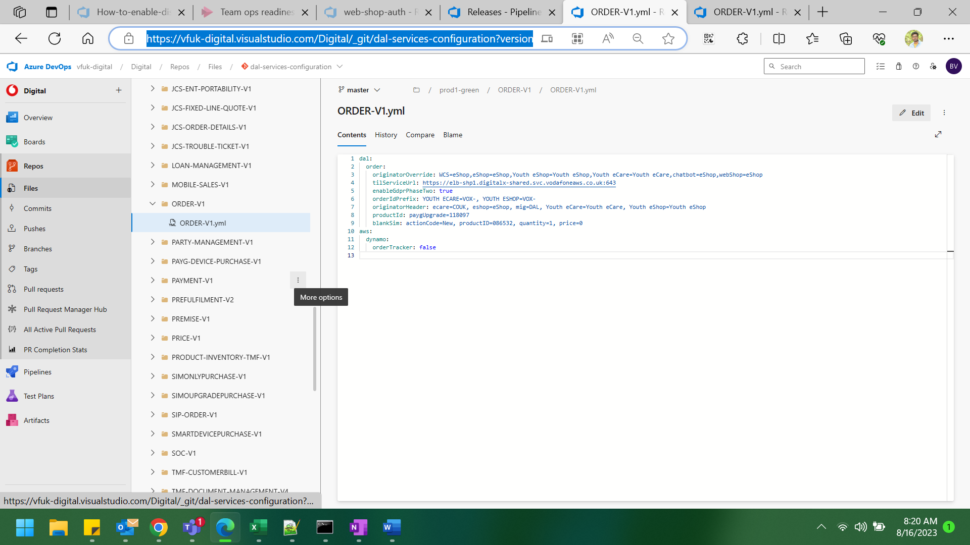
4. Create a sub branch and change the Value in the “Order Tracker” field in the repo

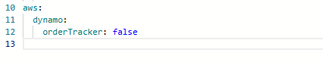

1. Now Make the value as “FALSE” as Order tracker to be disabled
2. Make the value as “TRUE” as Order tracker to be enabled
3. Post changing the values save the code accordingly.
4. Create PR and take approvals post create release under dal-services-configurations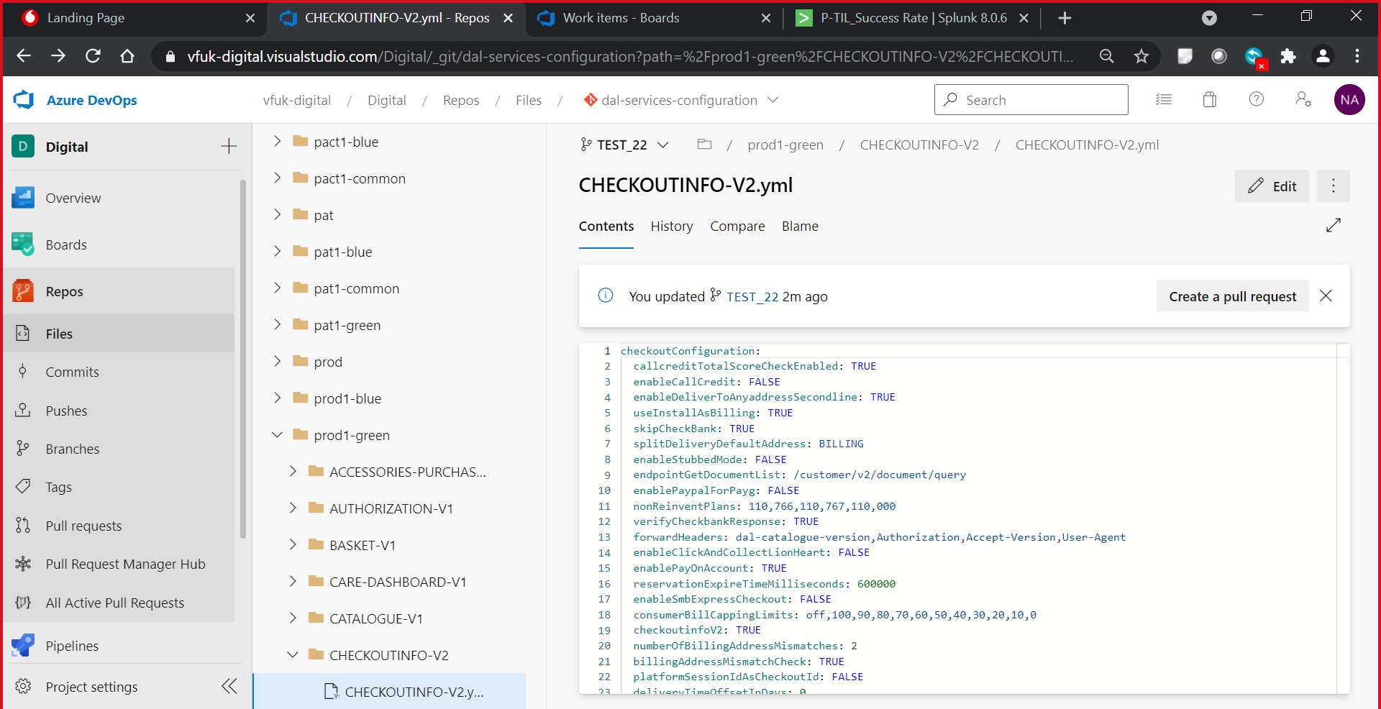
5. Deploy in prod1 green variable